**Express Route**

We want to connect on-premises network to azure dedicatedly. In this traffic does not go to internet. This connection is private.

We get seacurity,speed,low latency

We also connect PAAS service like SQL,O356,storage etc

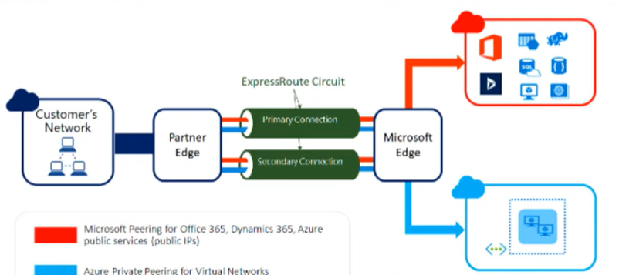

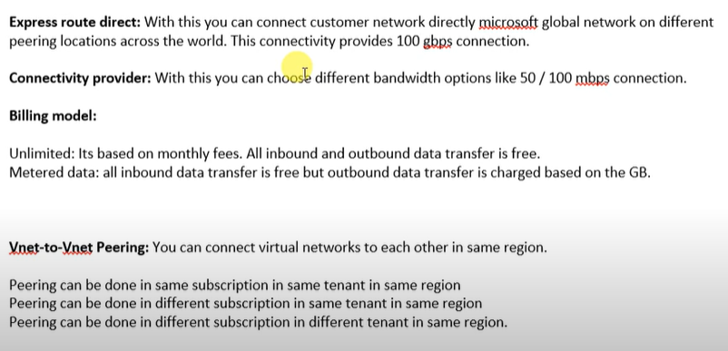

Configuration:

* Search express route circuit
* Click create
* Choose RG
* Give name

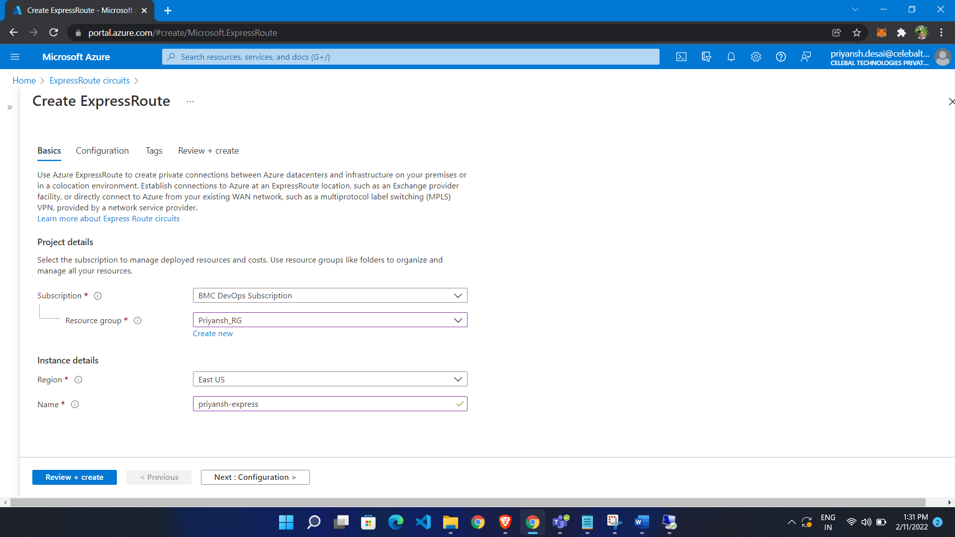

There is 2 type of port type

* Provider – we have to select provider
* Direct – we have to make direct express connection
* Choose provider
* Select location
* Select bandwidth

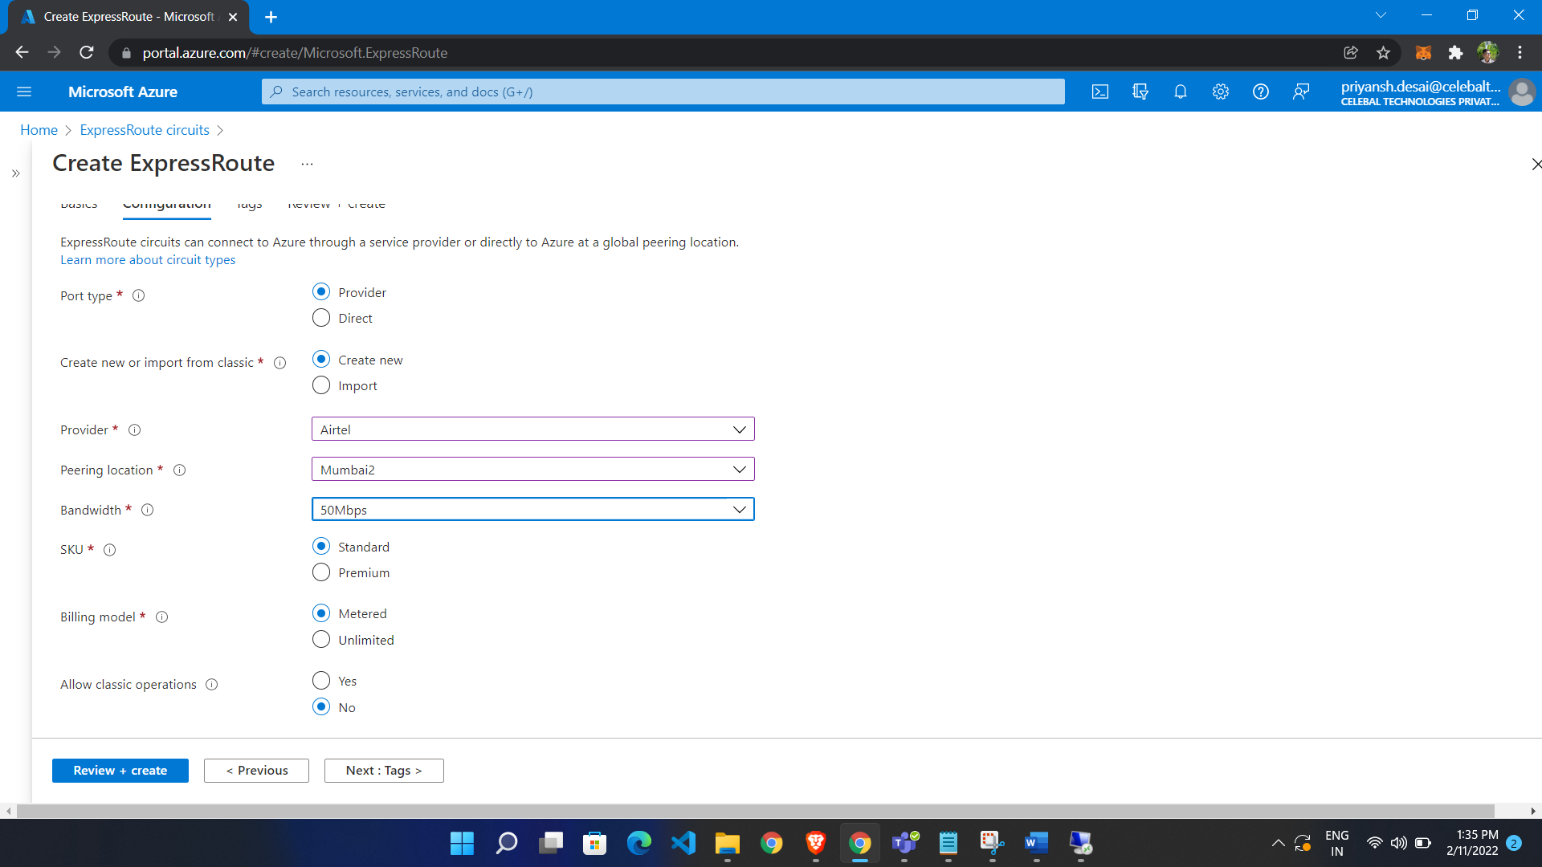

Circuit is enable but not provisioned

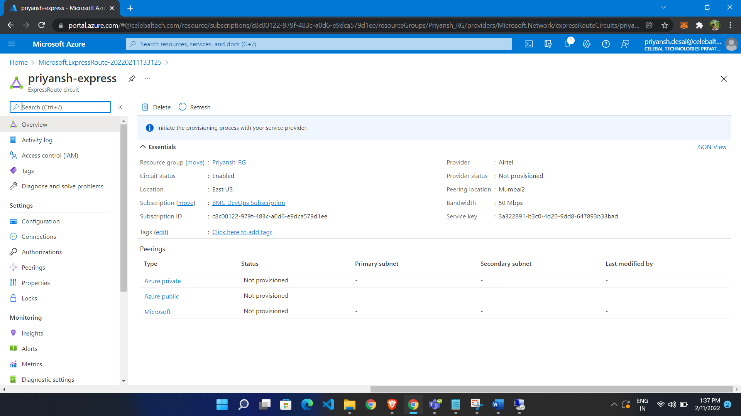

3 type of peering

